- Create user with name Techie and provide sudo access to user.
- Navigate to the home directory.
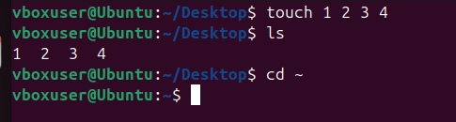
- Create a new directory.
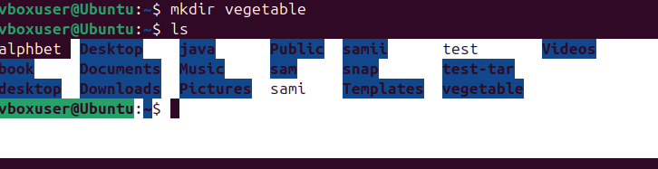
- List the contents of a directory.
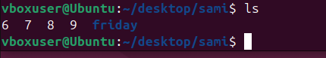
- Change the current directory.
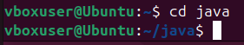
- Create a new empty file.

- View the contents of a file.
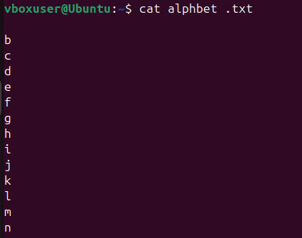
- Copy a file to another location.
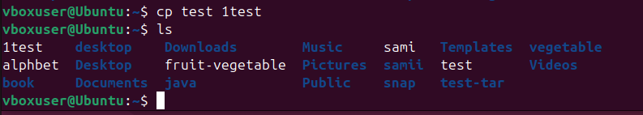
- Move a file to another location.
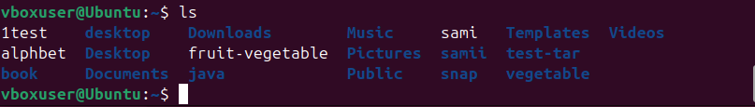
- Rename a file.
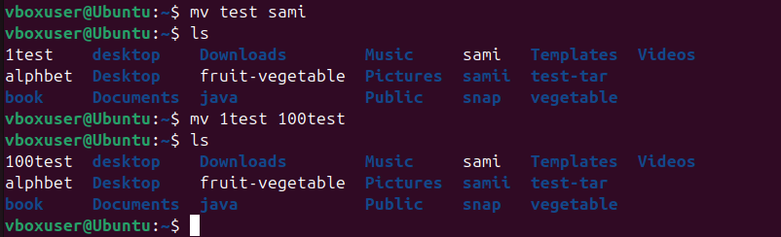
- Delete a file.
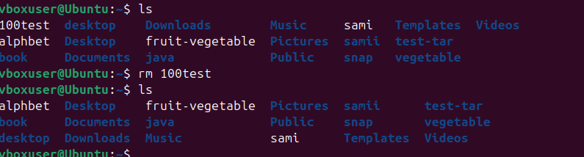
- Grant or revoke permissions on a file or directory.
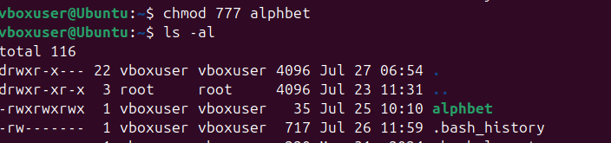
- View the current date and time.
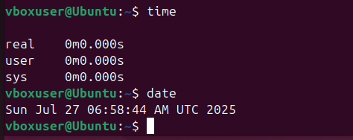
- Check the system uptime.
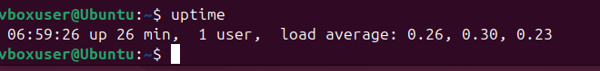
- View the running processes.
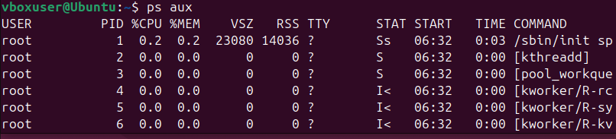
- Kill a running process.

- Install a package using the package manager (e.g., apt or yum).

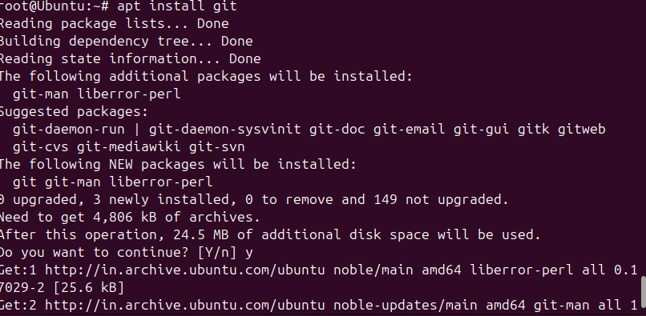
- Update the system packages.
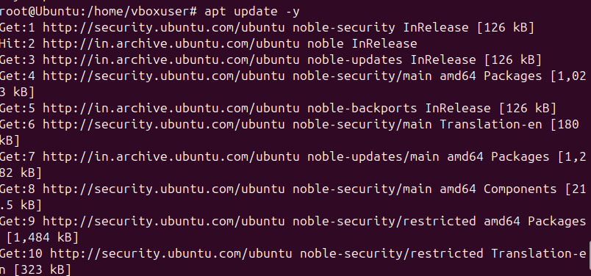
- Create a symbolic link.
Ln –s home/vboxuser/dev ops_link
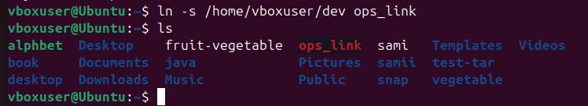
- Search for files using the find command.

- Compress and decompress files using tar.

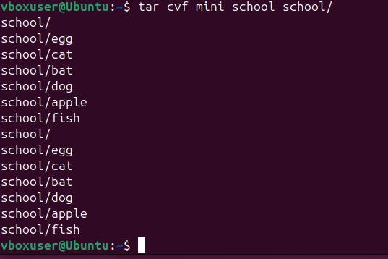

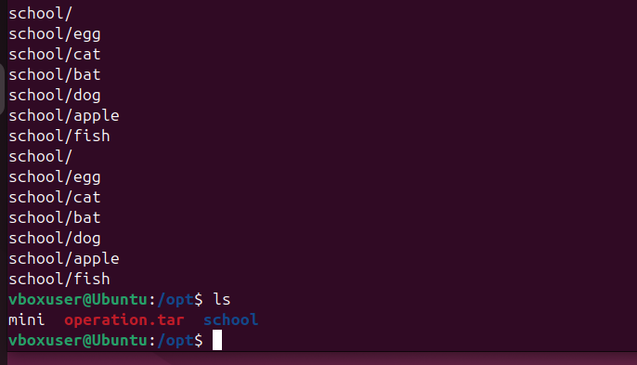
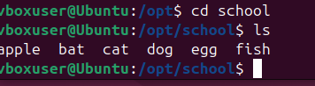
- Monitor system resources with top or htop.
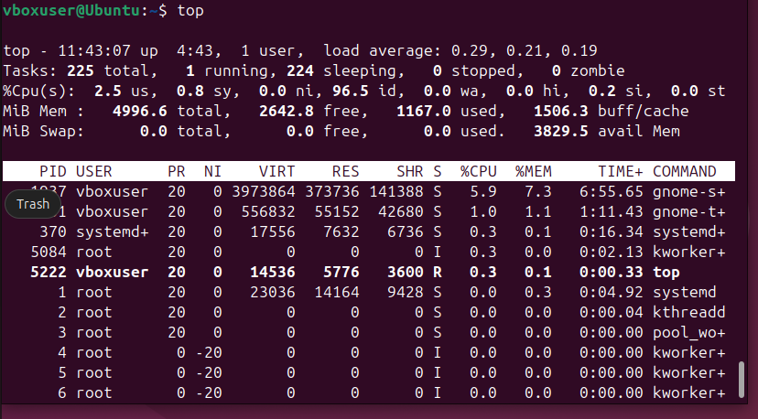
- Create and manage user groups.
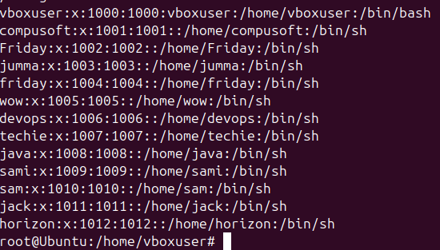

24) Set up SSH password less authentication.
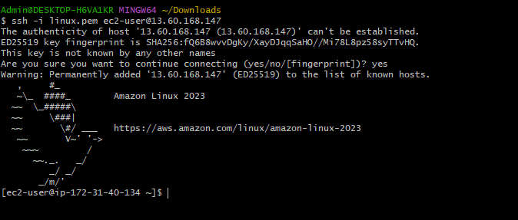
25) Monitor log files using tail or grep.
26) Set up a web server (e.g., Apache or Nginx).
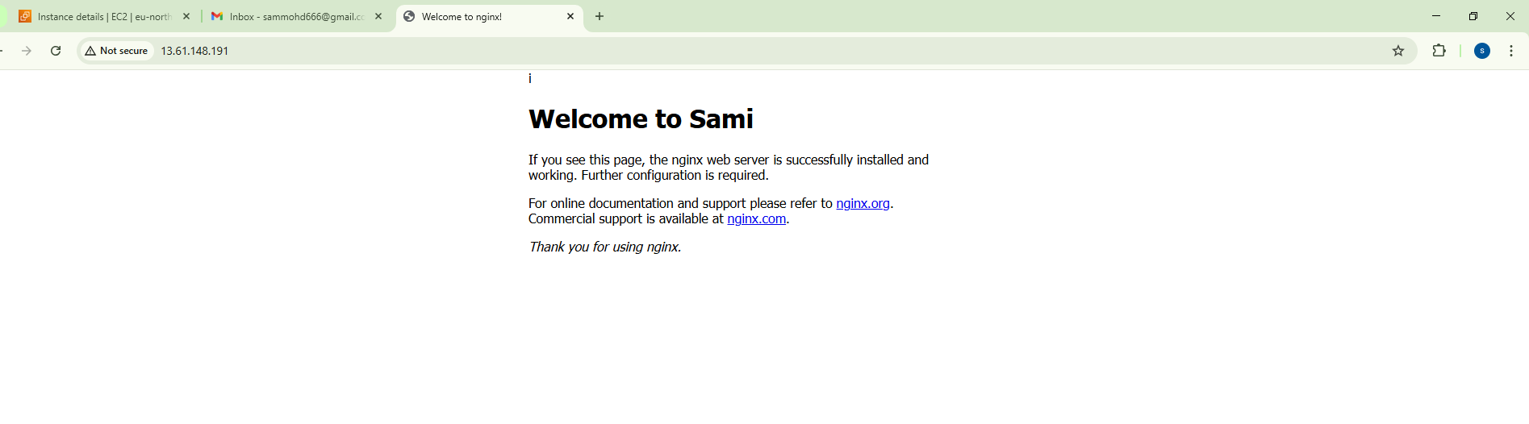
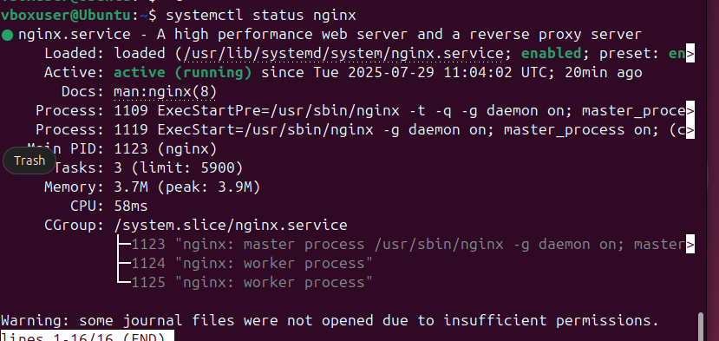
27) Configure and secure a MySQL Database.
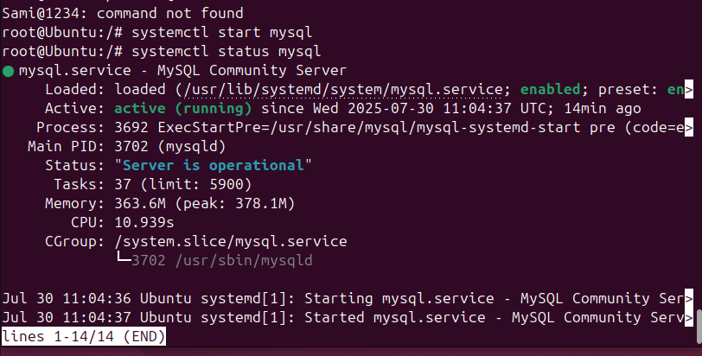

28) Set up a Application Server (e.g.,Apache Tomcat)
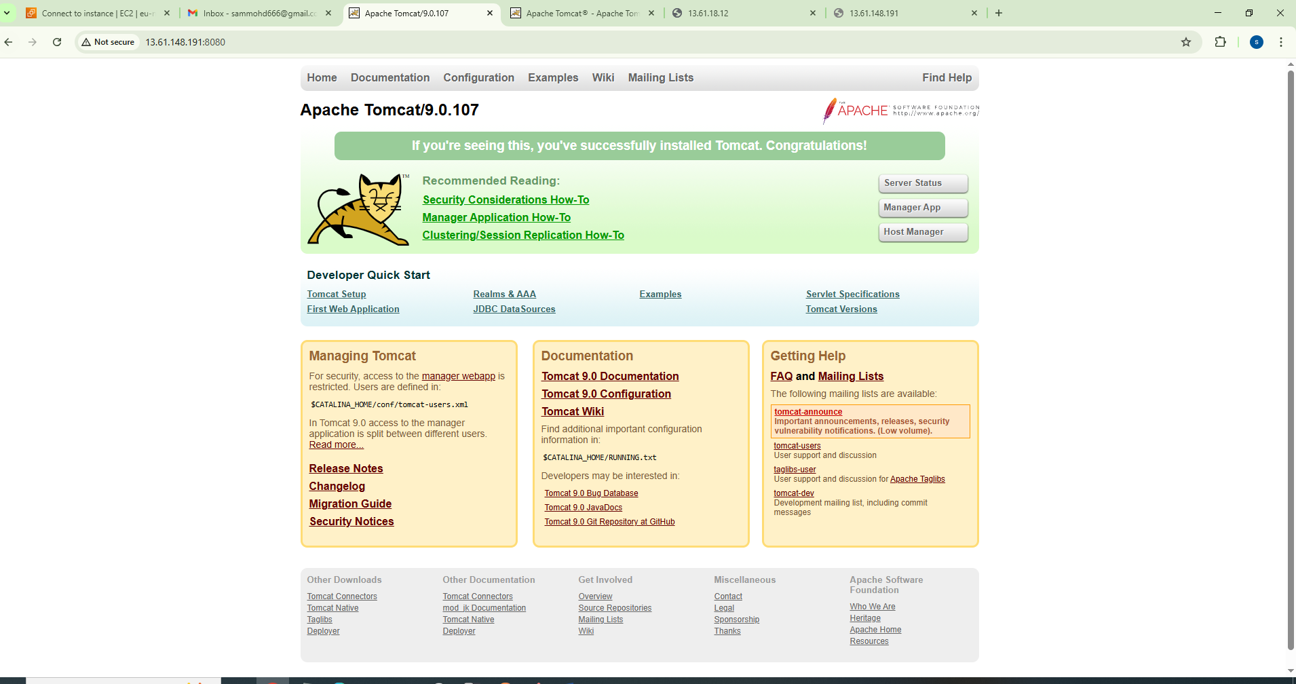
29) create a service file for Apache Tomcat.(Should execute by using systemtctl command)
30) Print specific columns from a delimited file.

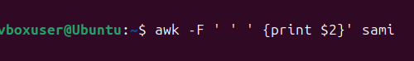

31) Filter and print lines based on a specific pattern or condition.
Grep –I d alphbet
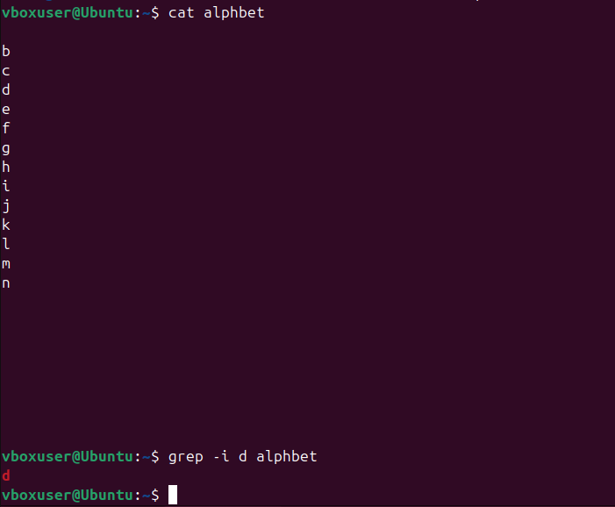

32) Calculate and print the average, sum, or other statistics of a column.
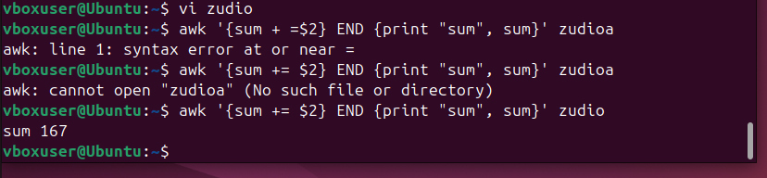
33) Perform string manipulation, such as extracting substrings or changing case.
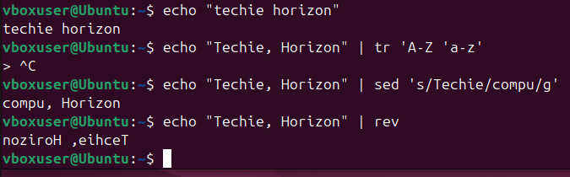
34) Count the occurrences of a specific pattern in a file.
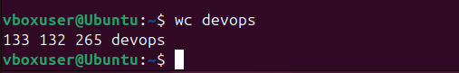
35) Sort lines based on a specific field or column.
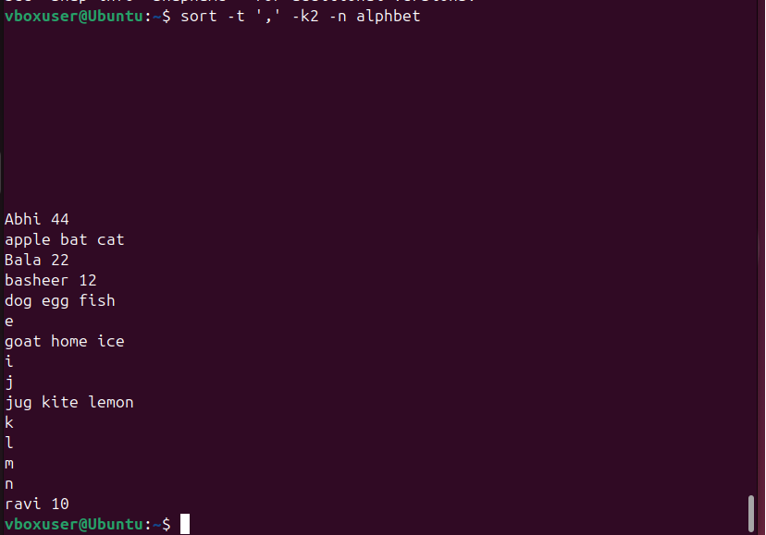
36) Merge multiple files based on a common field or column.
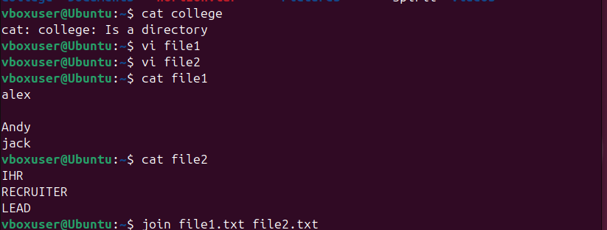
37) Substitute text in a file using search and replace.
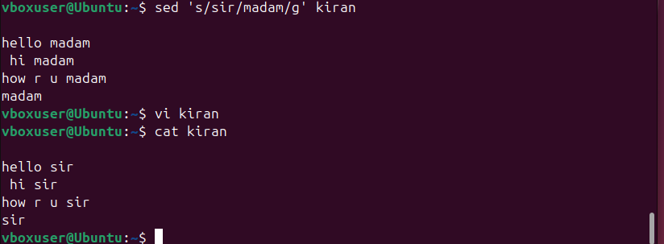
38) Delete specific lines based on a pattern or line number.
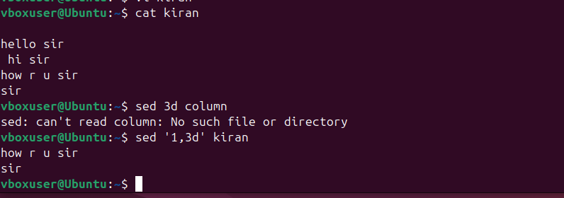
39) Append or insert text before or after a specific pattern or line.
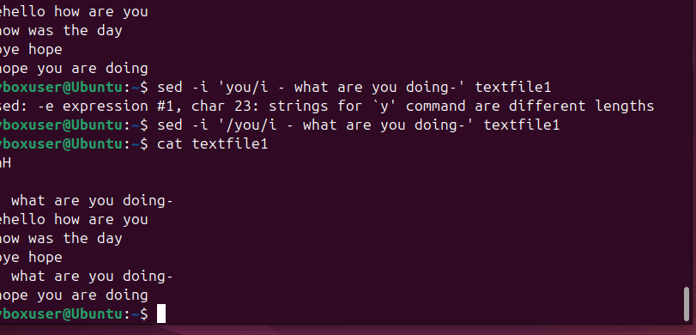
40) Print only specific lines from a file.
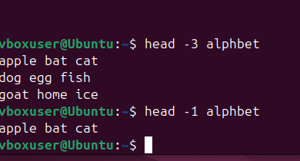
41) Copy file from linux to windows machine
42) 5 use cases for AWK and 5 use cases for sed
This command prints first text(AWK command is used to cut)


Deleted line 3 
